Talking Stick
A “Talking Stick” is a sacred tool often used during important gatherings within First Nation communities. It allows for a conversation to have purpose and respect. In a classroom setting we have used a Talking Stick to discuss topics such as our feelings or something that may concern us as a whole group. We all are in a time where healing and talking will help us get through these tough times. This activity is intended for the whole family to join in!

Activity
Task #1
- Go outside as a family and search for the perfect stick.
- Decide how you are all going to make your talking stick special.
- You may paint, bead, place ribbon/yarn, or maybe you just want to keep it in its natural form. The choice is yours!
Task #2
- Decide on a time as a family where you would like to discuss a topic.
- You may have something exciting you would like to talk about.
- You may want to discuss your feelings or emotions you may have.
- You may just want to spend time with your family talking without electronics.
- Remember those who have the Talking Stick are the only ones able to speak at this time.
- This task is meant to be sacred and respectful.
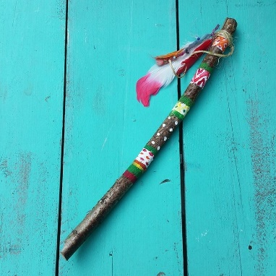
The following link gives you further information about the sacred protocols behind a talking stick. https://www.ictinc.ca/blog/first-nation-talking-stick-protocol
If you would like to show off your artwork you may email it to me at Molly.Brown@nbed.nb.ca Woliwon, Miss Topkwancihte

